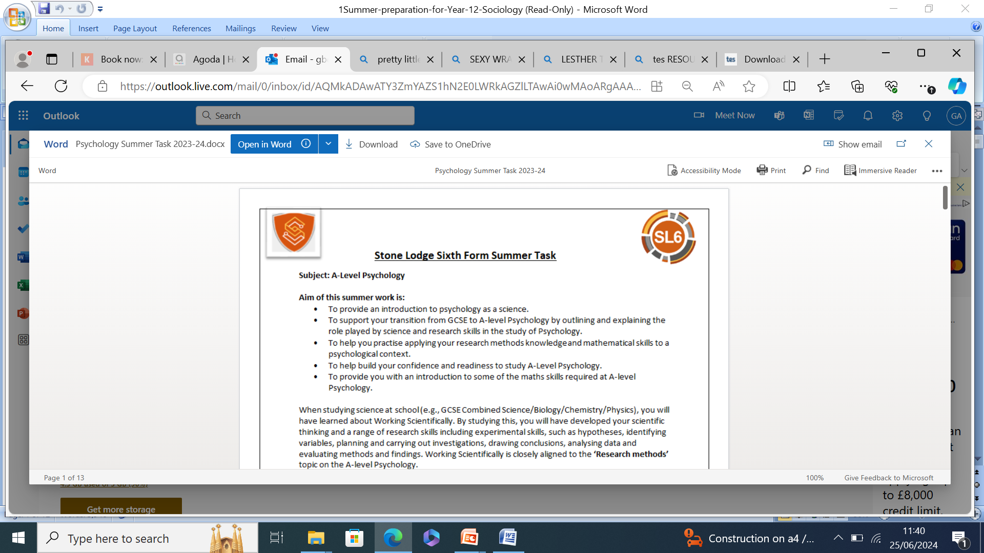
Summer preparation for Year 12 Sociology


Subject: A Level Sociology. 2 years
Subject summary:
A Level in Sociology will inspire you to reflect upon the world we live in, fostering an understanding of the inter-relationships between individuals, groups, institutions and societies. It will enable you to refine critical thinking and appreciate theoretical and conceptual issues

Key skills that you will need and develop during this course are:

Analytical skills – This is necessary to detect subtle connections between various social variables and theorise about the significance of certain cultural norms, demographic trends, or policies
Communication skills - Effective written and verbal communication skills are crucial for sociologists. You must communicate your research findings both verbally and at times orally in a coherent manner
Critical thinking skills - In sociology, you'll be thinking and talking about complex problems and theories that will require you to give serious critiques and arguments
Research skills - Having strong research skills is also critical for sociology because it requires you to survey populations
Comprehension skills - To develop habits of perceptiveness of noticing and understanding the reasons behind others’ responses
Evaluations skills – This skill is mandatory for the questions with more marks s as you’ll need to highlight limitations of research studies, theories and perspectives and often provide your opinion on them

AQA Sociology (7192)
Specification: AQA | AS and A-level | Sociology | Specification at a glance

On the following pages, you will find a selection of articles and suggested activities to prepare you for Year 12 Sociology.

The topics that we currently offer are:
- Education

- Methods in Context
- Theory and Methods
- Crime and Deviance
- Families and Households
- Beliefs in Society

The textbooks that we use in school are:
- Sociology for AQA. Vol 1. (ISBN: 978-0745691305)
- Sociology for AQA. Vol 2. (ISBN: 978-0745696942)

Textbooks are not mandatory but may support you in your private study periods and at home. The department has several textbooks available for you to use at school.

If you choose to buy your own, please look around on several websites to save you money! (The books below can be purchased on Amazon)







Sociology is everywhere, so you’ll be able to see aspects of it in all forms of media. Try searching for the following titles and make notes on any videos you watch, try to keep it relevant to the topics taught in Sociology (see above).
- School Swap documentary
- Stacey Dooley documentaries (BBC iPlayer / Youtube)
- Black Mirror (Netflix)
- Louis Theroux documentaries
- Dispatches documentaries (4OD)
- Panorama documentaries (BBC iPlayer)
Make any notes from your video observations here:

Nation of shoplifters: the rise of supermarket self-checkout scams

Alex Moshakis. Sun 20 May 2018
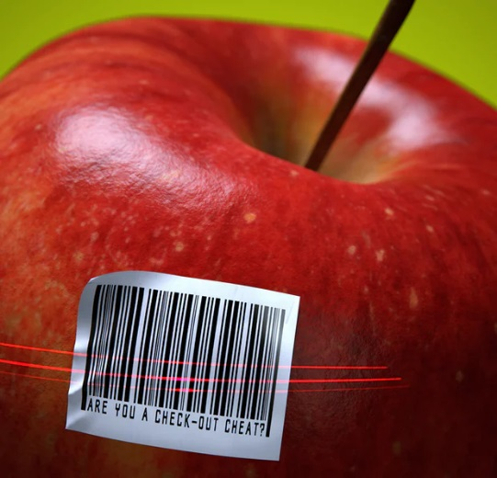
A couple of Tuesdays ago, after a difficult day at work, a thing that happens to me more often than I’d usually care to admit happened once again. At a supermarket self-checkout machine a frozen pizza I tried to swipe wouldn’t register, leaving me irked and full of spite. As a kind of reproach, I prepared to bag the item in any case, but a pang of weary guilt set in. Two choices sprung to mind. Carry on as though nothing untoward had happened, and knowingly steal. Or hail the cashier, who at the time was busy at another till, to fix the machine and right the wrong.
Some scams have names: 'the banana trick', 'the switcheroo', 'sweethearting'
I picked the second option, eventually. Though, to be honest, on another day I might have swayed the other way. Plenty of us do. Need proof? Look online, perhaps at a Reddit thread, and you’ll find anecdotes of petty self-checkout theft delivered with something like a stick-it-to-the-man pride. Expensive grapes are scanned as inexpensive carrots. Prime steaks are swiped as potatoes. The barcodes of pricey objects – wine, beer, spirits, cosmetics – are deliberately obscured by stickers removed from significantly cheaper on-sale items. Some scams have names – “the banana trick” (steaks as potatoes), “the switcheroo” (cheap barcodes for pricey ones), “sweethearting” (when a checkout supervisor only pretends to scan an object before handing it to a loved one, gratis) – though there are so many techniques not all of them do. Everyone’s at it
For an idea of how close to home the issue really is, try mentioning it to your friends, like I did. Several of mine confessed to pilfering something from a self-checkout machine at some point, though nearly all of those added a caveat: only small stuff. One recently got away with an umbrella. “Must have forgotten to swipe it through,” she said. Another regularly declares chocolate croissants as bread rolls. And more than a few said they bagged items that failed to scan, half-shifting the blame on to a faulty machine. “A couple of times I tried exotic fruits as potatoes,” a friend wrote in a text one morning. “But a checkout lady once caught me with mangoes, very embarrassing, and I didn’t do it much after that.” He ended the message with an Emoji of a face beneath a halo. “Now I’m a saint, although sometimes I’ll take a five-pence bag if I’ve already paid and realise I need extra.” In a WhatsApp message, one friend confessed to regularly placing a single banana on the scales while nabbing an entire bunch, though that wasn’t all. Sometimes he fills the bagging area “so there’s no room left for more shopping and I’m forced to put items on the floor,” which circumvents the “unexpected item” message we all dread. “I really like the game,” he said. “It’s about being crafty, sneaky – and outwitting them.”
When they turned up last decade, self-checkout machines were supposed to represent a new dawn in minimum-fuss shopping, though they’d been around since 1984. The till’s inventor, David R Humble, had introduced the technology at an LA trade convention, describing it at the time as “a revolutionary product” that “will sweep all of retail”. (To hammer home the point, he had an 11-year-old provide a demonstration. “Many marvelled,” the Los Angeles Times reported.) When they reached stores, the machines offered customers unexpected levels of autonomy, and the opportunity to avoid long queues at traditional checkout tills. And though the machines were outwardly advertised as being strictly beneficial for the customer, they offered retailers perks, too, notably the freedom to slash labour costs. The more self-checkout machines a supermarket had, the fewer cashiers it required. There were savings to be made.
But any financial gains now appear to be marginal, at least in part due to unforeseen spikes in self-scanning theft. In a recent study a team at Voucher Codes Pro, a sales coupon website, quizzed 2,532 shoppers about their supermarket habits and found that close to a quarter had committed theft at a self-checkout machine at least once. (A figure from the same report suggested that the total cost of items stolen through self-checkout machines in 2017 came in at more than £3bn, up from £1.6bn in 2014, though the numbers are speculative.) Some steal by accident, the study found, perhaps on account of a scanning error – honest mistakes. But many perpetrators know exactly what they’re doing.
In 2016, criminologists at the University of Leicester published a paper that reported on the impact of recent developments in mobile-scanning technology. The study was led by Adrian Beck, an emeritus professor of criminology, who has spent more than 25 years researching losses in the retail industry. In the report, he’d suggested that retailers who rely on self-scanning technology inadvertently create environments that encourage theft. In the self-checkout aisle, for example, human interaction is often pared back to a minimum, which reduces the perception of risk on the part of a potential perpetrator. “It’s about the degree of opportunity it provides people who wouldn’t normally do something deviant,” explains Beck. “It presents them with opportunities they wouldn’t normally have.”
A couple of times I tried exotic fruits as potatoes, but a checkout lady caught me. Embarrassing
As Beck sees it, the customer who reaches the self-checkout machine and knowingly bags a frozen pizza after it fails to register isn’t a typical thief. “This guy didn’t get out of bed that morning and say, ‘I can’t wait to be a shoplifter today,’” Beck told me. “And he didn’t walk down an aisle and put something in his pocket.” In most cases, perpetrators are otherwise honest. They tend not to employ traditional shoplifting techniques, and are unlikely to steal in circumstances in which an opportunity is not presented to them. Psychologists call this Opportunity Theory – when an offender consciously decides to take advantage of an opportunity for crime that has appeared in his normal routine. But there is other psychology at play, too. Often, perpetrators will construct what they perceive as legitimate excuses for theft. Some feel justified in taking items when the checkout machine they’re using doesn’t operate smoothly (it’s the machine’s fault). Others consider the items they steal as a kind of payment for work they’re completing on the supermarket’s behalf.
Still more reach the self-checkout machine, look around, and see nothing but the inhuman trappings of a faceless corporation. Few would steal from an individual grocer. But from a multinational conglomerate? What difference does it make? “There’s a mountain of good socio-cognitive criminological research that explains this under the heading of Neutralisation Theory,” says Shadd Maruna, a criminology professor at the University of Manchester. I’d asked him to take me through the psychology of self-checkout theft, to help me get to grips with the “why”. “Individuals can neutralise guilt they might otherwise feel when stealing by telling themselves that there are no victims of the crime, no human being is actually being hurt by this, only some mega-corporation that can surely afford the loss of a few quid. In fact, the corporation has saved so much money by laying off all its cashiers that it is almost morally necessary to steal from them.”
Maruna offered a personal example to illustrate the point. “Twice in the past month I have handed back change to a cashier when I was given too much,” he said. “I did this because I was worried that the individual, working for minimum wage, would have the money taken out of their own pocket if the cash till was short at the end of the workday. Had the same thing happened and a machine gave me the wrong change, there’s no question I would have pocketed it.” He finished with a flourish: “Screw them!”

Frictionless shopping
When I asked several supermarkets to comment on this story, they all declined. Later, when I visited a few of my local stores and asked cashiers about their experiences, most seemed initially open to revealing all before loyalty (or self-preservation) led them to pass the request up the chain to their shift managers, who each delivered a variant of the same message: “Ask head office.” Supermarkets, it seems, would prefer not to spill the beans.
Which isn’t unwise. The subject is fraught with uncertainty. Often it is difficult for retailers to discern between malicious actions and honest mistakes – was the customer absent-minded or consciously fraudulent? – and proving intent can be perilous. Charge an honest shopper with theft and lose their business. Let a perpetrator off the hook and suffer a reduction in profit. Beck describes the scenario as “a legal and customer relations minefield”.
Shift managers I asked all said the same thing: 'Ask head office'
Still, supermarkets are persevering with self-checkouts. According to a BBC report, by 2021 there will be 468,000 around the world, up from some 240,000 in 2016. And retailers aren’t stopping there. Amazon is pursuing plans to create stores in which checkouts are eradicated entirely. Computer vision and artificial intelligence will align to keep track of the items in a shopper’s basket, allow them to walk in and out of the store without any human interaction, and later email them a receipt and charge their account. Chinese retailers aren’t far behind.
Soon, supermarkets might be entirely human-free – what they refer to in the industry as “frictionless”.
Where will that leave us? Customer convenience will rise. The conflicts we sometimes face on a shopping run will reduce to faded memories, and long till queues will be vanquished. So, too, will staff. Cashiers will be diverted to different sections of our stores, ostensibly to better help customers mid-shop, until they will disappear altogether, along with human interaction, the one thing that seems to keep us on the straight and narrow.
Would you consider this a crime? Is this deviant behaviour? How could this impact society and the economy?


Marriage between heterosexual couples is at the lowest level on record
28 February 2018
New research has revealed that marriage between heterosexual couples is at the lowest level on record.
The new study by the Office for National Statistics (ONS) revealed that 239,020 between heterosexual couples took place in England and Wales in 2015, a 3.4 decrease on the year before.
Between 1972 and 2009, a gradual long-term decline in the number of marriages was gradually noticed, before the trend was eventually bucked between 2010 and 2012. But in 2015, The number of marriages was 0.8% lower than the record low of 2013, representing the lowest number of marriages in a calendar year since 2009. The data also shows a steep decline in tradition, with only 0.7 percent of same sex marriages being performed at a religious ceremony. Despite the overall decline, it also appears that heterosexual couples are getting married later in life, with the the average age for men marrying in 2015 being 37.5 years, while for women it was 35.1 years.
It reflects an increase compared with 2014 (37.0 years for men and 34.6 years for women) and continues the overall rise which has been recorded since the 1970s. For the first time ever, the date also reflected same sex marriages – with 6,493 being performed in 2015. Of these, 44% (2,860) were between male couples and 56% (3,633) were between female couples. Statistician Nicola Haines said: ‘Marriage rates for opposite-sex couples are now at their lowest level on record following a gradual long-term decline since the early 1970s. The number of marriages between opposite-sex couples decreased by 3.4% in 2015, compared with 2014.
‘Despite this overall decline, marriages at older ages rose; the number of weddings increased for men aged 50 and over and women aged 35 to 39 years and 45 and over. ‘This is the first full year for which marriages were available for same-sex couples and they accounted for 2.6% of all marriages.’
Suggest why marriages are declining in British society.

As few as one in 20 born in poorest areas go to university
14 August 2017

Only one in 20 pupils in some of the country's poorest postcodes progress to higher education, according to new analysis by Teach First.
The charity has called for the government to improve entry rates by writing off student debt to get better teachers into challenging schools. It has also called on universities to start offering university access programmes at primary level.
According to Teach First's research, on average only one in five young people born in the country’s poorest postcodes progress to university, while half of those born in the wealthiest postcodes do so. However, the gap is even more stark between some areas.
For example, in some parts of Derbyshire, as few as one in twenty students go to university, while in parts of Buckinghamshire it is more than 80 per cent. This means that those born in some of the richest areas are up to 18 times more likely to attend university than those in some of the poorest areas. Teach First also found big differences between the choices made by disadvantaged young people when it came to university compared to their more privileged peers.
A ComRes poll of 18-25 year olds found that 41 per cent of the most advantaged students said they chose their university because it was the best for what they wanted to study, compared to only 31 per cent of the least advantaged. Similarly, the reputation of a university was important to 53 per cent of the most advantaged students, but it only was for 46 per cent of the most disadvantaged. Disadvantaged students are also more likely to choose an institution close to where they live, with 29 per cent saying they chose their university on this basis, compared to 24 per cent of the most advantaged. Of the most disadvantaged pupils who did not go to university, only 12 per cent said this was because their grades weren't good enough.
To ensure students were able to make more informed choices when it came to university, Teach First said there should be a trained careers middle leader in every school to develop and lead a careers strategy. It suggested this could be paid for out of money councils and academies are required to set aside for the apprenticeship levy.
Teach First says the government should offer student loan forgiveness to attract the best possible graduates into teaching, where they can help young people from deprived communities achieve their potential.
It suggests 20 per cent of student debt could be cleared for those working for two years, increasing to 50 per cent for those who remain in certain geographic or subject areas for five years. The charity also says that universities' access work is coming too late, with programmes frequently aimed at pupils aged 16-18 "by which point much of the effects of disadvantage have already played out". Instead, it argues that access work should start at primary school to give pupils "the best possible opportunity to make informed and supported decisions about their futures at an earlier age".
Brett Wigdortz, Teach First's chief executive and founder, said "there are still far too few disadvantaged pupils getting to university". "They’re simply not given the same chance to reach their full potential, with less access to brilliant teaching and less guidance on how they can turn their aspirations into reality. "He added: “More must be done by the government, universities and society as a whole to break down the barriers to social mobility that are preventing too many of our young people reaching as far as their potential allows”.
What is meritocracy?
Does this article suggest we live in a meritocracy?
Why is it important that ‘poor’ students go to university?

