Stone Lodge Sixth Form Summer Task
Subject: A-Level Psychology

Aim of this summer work is:
- To provide an introduction to psychology as a science.
- To support your transition from GCSE to A-level Psychology by outlining and explaining the role played by science and research skills in the study of Psychology.
- To help you practise applying your research methods knowledge and mathematical skills to a psychological context.
- To help build your confidence and readiness to study A-Level Psychology.
- To provide you with an introduction to some of the maths skills required at A-level Psychology.

When studying science at school (e.g., GCSE Combined Science/Biology/Chemistry/Physics), you will have learned about Working Scientifically. By studying this, you will have developed your scientific thinking and a range of research skills including experimental skills, such as hypotheses, identifying variables, planning and carrying out investigations, drawing conclusions, analysing data and evaluating methods and findings. Working Scientifically is closely aligned to the ‘Research methods’ topic on the A-level Psychology.

Details of task to be completed (2-3 hours) and submitted in your first lesson:

- Activity 1: Research methods
- Activity 2: Psychology and science
- Activity 3: Applying science to psychology
- Activity 4: Exploring correlational data
- Activity 5: The Stroop test

Activity 1: Research Methods
Add a clear definition to each of the terms in the table below. These links may help:
https://www.tutor2u.net/psychology/reference/revision-note-independent-and-dependent-variables
https://www.simplypsychology.org/what-is-a-hypotheses.html

Term | Definition
Hypothesis
Independent Variable
Dependent Variable

Activity 2: Science and Psychology
Before applying your Working Scientifically knowledge and skills to psychological contexts, firstly complete some past paper questions from science. This will serve as a reminder of your knowledge of hypothesis, independent and dependent variables.
Question 1
Almost 200 years ago, an important investigation into plant growth was carried out.
George Sinclair, the Duke of Bedford’s head gardener, planted seeds in 242 plots of land,
each four feet square.

Charles Darwin concluded from this investigation:
If a plot of ground is sown with one species of grass and a similar plot is sown with several
different species of grass, the second plot will produce a greater number of plants and a
greater mass of plant material.

What two factors are named in Darwin’s conclusion as the measurable outcomes in
the investigation?
(These are the dependent variables.)

- ..............................................................................................................................................

- ..............................................................................................................................................
[1 mark]
Question 2

Caffeine is a drug found in coffee.
After a person drinks coffee information passes through neurones in the nervous system more quickly.
Suggest a hypothesis for the effect of caffeine concentration on reaction time.

..........................................................................................................................................................

..........................................................................................................................................................
[1 mark]

Question 3

Jason wanted to find out if hair dye makes hair weaker.
He used 5 hairs of equal length.
He soaked each hair in a different concentration of hair dye for 15 minutes.
He added masses to each hair until it broke.
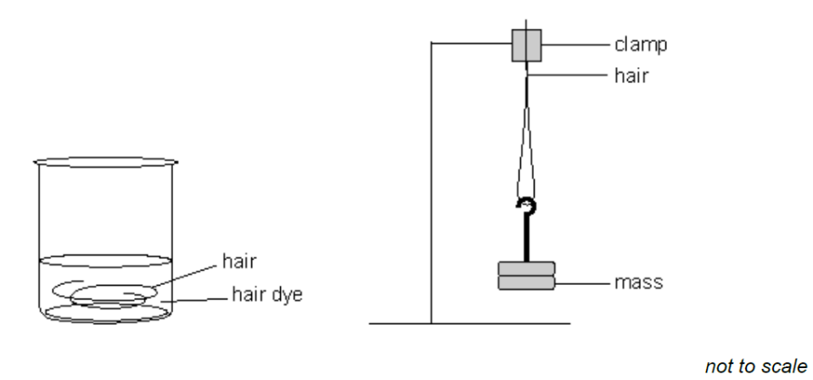

- What was the independent variable?
...............................................................................................................................................[1 mark]
- What was the dependent variable?
...............................................................................................................................................[1 mark]
Question 4

Two groups of pupils investigated the factors affecting the time taken for an indigestion tablet to dissolve in 100 cm³ of water.
Group 1 recorded their results in the table below.

Results of Group 1
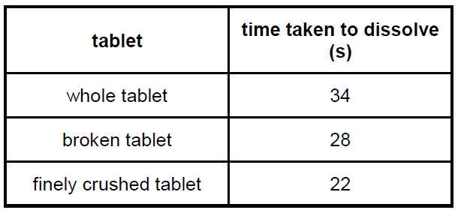

- What factor did Group 1 change as they carried out their investigation?
...............................................................................................................................................
[1 mark]

Group 2 investigated how the temperature of the water affects the time taken for a whole tablet to dissolve. Here are their results.

Results of Group 2
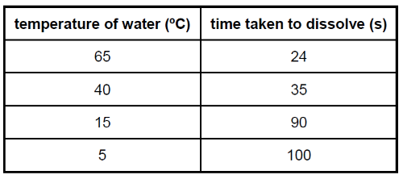

- What factor did Group 2 change as they carried out their investigation?
...............................................................................................................................................
[1 mark]
- What pattern do the results recorded by Group 2 show?

...............................................................................................................................................
[1 mark]

Question 5

Neera and Tom dissolved different masses of salt in 500 cm³ of water.
They measured the temperature at which each salt solution boiled.

- What is the independent variable in their investigation?

...........................................................................................................................................................
[1 mark]
- What is the dependent variable in their investigation?

...............................................................................................................................................
[1 mark]

Activity 3: Applying Science to Psychology
Before completing the Psychology questions, it is useful to consider how to write an effective hypothesis in Psychology.
- It should be a clear, testable statement (do not present in the form of a question).
- Both conditions of the independent variable are stated within the hypothesis.
- The dependent variable is operationalised (ie it is clear how it was measured).
Consider this example: ‘Students who have not eaten breakfast will answer fewer questions correctly than students who have eaten breakfast.’
Hypothesis | Yes or No
Is it a testable statement? | Yes
Are both conditions of the IV stated? | Yes – both conditions stated (eaten  breakfast/not eaten breakfast).
Is it clear how the DV was measured? | Yes – measured by the number of questions  answered correctly.

Complete the following past paper questions from Psychology:
Question 1
A Psychology teacher had the idea that her students were more alert in the mornings than in the afternoons. To test this idea, she conducted an experiment.
This is what she did.
- She measured alertness by giving her students a page of writing to read that contained 30 spelling errors. They had to find these errors.
- She gave each of her students two minutes to underline every error that they could find.
- She then counted the number of errors that they correctly underlined.
- 19 students took part in the experiment. She used random allocation to assign the students to
- either Condition A or Condition B.
- In Condition A the students completed the task in the morning.
- In Condition B the other students completed the task in the afternoon.

- Identify the dependent variable in this experiment. Tick the correct box.

Whether participants worked in the morning or afternoon
The 30 errors
The number of errors correctly underlined

- Write a suitable hypothesis for this experiment.
...............................................................................................................................................

...............................................................................................................................................
[2 marks]
Question 2
A psychologist conducted an experiment to find out if people reacted more quickly to a ringing bell or to a flashing red light. Each participant sat in front of a machine which could make a sound like a ringing bell, or could flash a red light. The participant had to press a button on the machine immediately when they:
- heard a bell ring or
- saw a red light flash.
The machine recorded their reaction times in milliseconds.
- Identify the independent variable in this experiment.
...............................................................................................................................................
[1 mark]
- Identify the dependent variable in this experiment.
...............................................................................................................................................
[1 mark]
- Write a suitable hypothesis for this experiment.
...............................................................................................................................................

...............................................................................................................................................
[2 marks]
Question 3
Read the item and then answer the questions that follow.
A psychologist conducted a memory experiment, showing people sets of numbers and then taking the numbers away and asking them to write down what they had seen.
- In Condition A, participants saw nine numbers written in groups of three for 10 seconds, for example, 746 826 392. They were then given 10 seconds to write down the numbers they had seen. This was repeated 10 times with different sets of numbers.
- In Condition B, the same participants saw nine numbers written in one group of nine for 10 seconds; for example, 746826392. The participants were given ten seconds to write down the numbers they had seen. This was repeated 10 times with different sets of numbers.
The psychologist recorded the total number of recall errors made by each participant.

- What is an independent variable?
...............................................................................................................................................
[1 mark]
- What is a dependent variable?
...............................................................................................................................................
[1 mark]
- Write a suitable hypothesis for this experiment.
...............................................................................................................................................

...............................................................................................................................................
[2 marks]
Question 4
A psychology teacher had an idea that students who study drama are more extravert than students who do not study drama. She wanted to find out whether or not this is true and decided to conduct an experiment. This is what she did.
- She asked all 30 members of her Year 11 psychology class whether or not they studied drama. She discovered that half of her class did study drama.
- After obtaining their consent to take part in the experiment, she asked every member of her class to complete the EPI (a personality test). The test measures extoversion. The higher the score, the more extroverted a person is.
- She calculated the mean extroversion score for the students who studied drama and the mean extraversion score for the students who did not study drama.
- Identify the independent variable in this investigation. Tick the correct box.
The EPI (personality test)
The extroversion score for each student
Whether or not the students studied drama
[1 mark]
- Identify the dependent variable in this investigation. Tick the correct box.
The EPI (personality test)
The extroversion score for each student
Whether or not the students studied drama
[1 mark]

- Write a suitable hypothesis for this experiment.
...............................................................................................................................................

...............................................................................................................................................
[2 marks]

Question 5
A Psychology teacher was worried that the temperature in her classroom was having an effect on her students’ performance in tests. She thought students performed better when the temperature was cool compared with when it was warm. She decided to conduct an experiment using two of her GCSE Psychology classes as participants.
This is what she did:
- One morning, she adjusted the classroom temperature to 25 °C (the warm condition). Then she gave a test containing 30 questions to the GCSE students who were in the classroom.
- Later that day, for her other class of students, she adjusted the classroom temperature to 18 °C (the cool condition). Then she gave the same test to these GCSE students who were in the classroom.
- To measure each student’s performance, she counted the total number of questions they answered correctly.
- None of the students in either class realised that they were taking part in the experiment.

- Identify the independent variable in this experiment. Tick the correct box.

The test containing 30 questions
The number of questions answered correctly
Whether the temperature was warm or cool
[1 mark]
- From the following statements, choose the one that is written as a testabe hypothesis for this experiment. Tick the correct box.
More will answer questions correctly when the temperature is cool compared with when it is warm.
Students will answer more questions correctly when the temperature is cool compared with when it is warm.
Students are more likely to answer questions better when the temperature is cool compared with when it is warm.
[1 mark]

Activity 4: Exploring Correlational Data

Correlational research: Key points
- Used to establish the relationship between two variables (known as co-variables).
- The data for correlation is gathered through methods such as surveys (questionnaires and interviews),and naturalistic observation (observation of naturally occurring behaviour).
- The data collected is statistically analysed to measure the relationship between the two co- variables.
- Correlations are plotted on a type of graph called a scattergram.
- There are different types of correlational relationships, for example positive correlations and negative correlations.
- There are different strengths of correlational relationships, for example: no correlation, weak correlation, moderate correlation, strong correlation.
- Correlation is an important technique when it would not be ethical to carry out an experiment in psychology.
- A limitation of correlational research is that the researcher cannot conclude a cause and effect relationship from correlational research as there may be another variable that has not been controlled.
Place the correct letter in the table below.
A – as one variable increases the other variable increases
B – as one variable increases the other variable decreases
C – there is no relationship between the variables
Type of correlation | Letter
Positive
Negative

Identify the type of relationship shown in the graphs below – identify whether it is a positive or negative correlation.
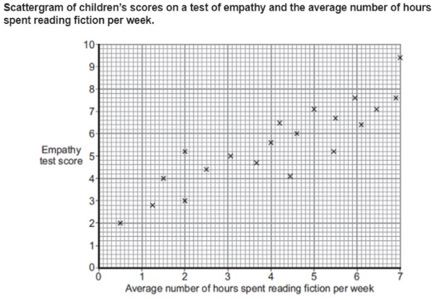  1. | 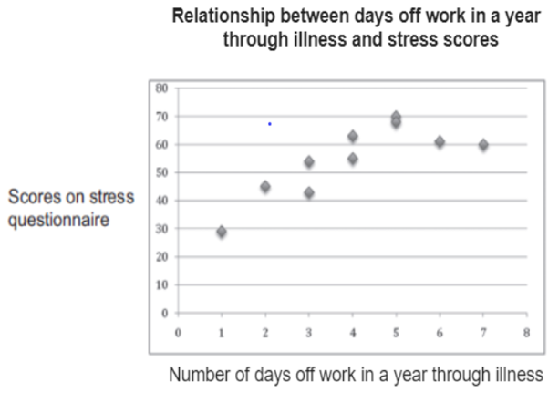  2.
Type of correlation: | Type of correlation:
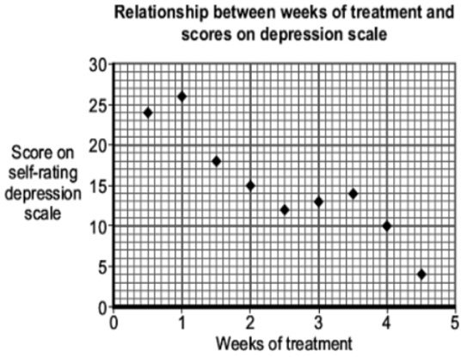  3. | 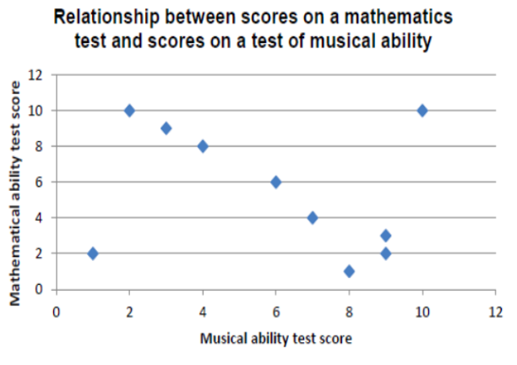  4.
Type of correlation: | Type of correlation:

Activity 5: The Stroop Effect Experiment

Use the information in the link below to answer the following question.
https://www.simplypsychology.org/stroop-effect.html
What is the Stroop effect?

Example of a Stroop test:
Instruction – participants are asked to name the colour of ink the word is printed in.
Congruent Condition  ‘Congruent’ means that the word and the colour of the ink match | Incongruent Condition  ‘Incongruent’ means that the word and the ink colour do not match
Red | Red
Yellow | Yellow
Green | Green
Blue | Blue
Black | Black

Try your own Stroop test using the link below then answer the questions:
https://www.psytoolkit.org/lessons/experiment_stroop.html
Identify the:
Independent variable
Dependent variable
Hypothesis

Using the online test (https://www.psytoolkit.org/lessons/experiment_stroop.html) ask 10 people you know to complete the Stroop test and record their speed (in milliseconds) during the stroop test for the congruent condition (word and ink colour match) and incongruent condition.
Participant | Congruent condition | Incongruent condition
Participant 1
Participant 2
Participant 3
Participant 4
Participant 5
Participant 6
Participant 7
Participant 8
Participant 9
Participant 10

Now calculate the mean and median for your results.
 | Congruent condition | Incongruent condition
Mean
Median
Comment on your results in relation to your hypothesis:

